Botswana

## Political Stability Estimate Data

The data set shows the political stability estimate of the country each year.

## # A tibble: 19 x 5  
## country iso3c date stability stabilityCategory4  
## <chr> <chr> <dbl> <dbl> <chr>   
## 1 Botswana BWA 1996 1.01 highly stable   
## 2 Botswana BWA 1998 0.955 moderately stable   
## 3 Botswana BWA 2000 1.07 highly stable   
## 4 Botswana BWA 2002 0.874 moderately stable   
## 5 Botswana BWA 2003 1.11 highly stable   
## 6 Botswana BWA 2004 0.916 moderately stable   
## 7 Botswana BWA 2005 1.06 highly stable   
## 8 Botswana BWA 2006 1.02 highly stable   
## 9 Botswana BWA 2007 1.06 highly stable   
## 10 Botswana BWA 2008 1.03 highly stable   
## 11 Botswana BWA 2009 0.953 moderately stable   
## 12 Botswana BWA 2010 0.991 moderately stable   
## 13 Botswana BWA 2011 1.06 highly stable   
## 14 Botswana BWA 2012 1.10 highly stable   
## 15 Botswana BWA 2013 1.10 highly stable   
## 16 Botswana BWA 2014 1.01 highly stable   
## 17 Botswana BWA 2015 1.04 highly stable   
## 18 Botswana BWA 2016 0.995 moderately stable   
## 19 Botswana BWA 2017 1.03 highly stable

## Political Stability Estimate Plot

The plot shows the trends of stabilization and destabilization for the each country.

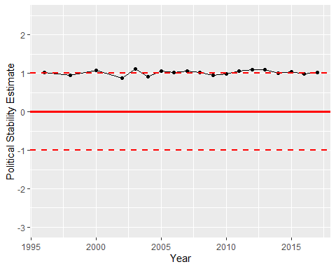

Political Stability Trend